Marston Parish Council Parish Council
Meeting Minutes
8th September 2026, 7pm Marston Chapel

Present: Cllr Philip Bellew (Chair),
Cllr Jonathan Nickell, Cllr Jon Robbins, Cllr Charlie Milton
Steve Bennet (Clerk)
Also Present :
Tamara Reay (Cllr Wiltshire Council)
Susan Bourne (Marston Village Green working group)
12 Members of the public attended the meeting

Item no. | Agenda item | Notes | Action
1 | Apologies for absence | Cllr Mark Cherrington,  Fiona Cassidy, Website and MVGWG  Dawn Whiting (minutes)  Lambert Courth (Parishioner) - MPC wish him a speedy recovery
2 | Declarations of interest | Cllr Nickell is a neighbour of Eastfield Farm and will not be involved in the comments for planning application PL/2026/04577.
3 | Approval of previous minutes | Meeting dated 14th July were signed off as a true and accurate record.
4 | Matters arising from previous minutes | Wessex Water has completed their planned work to the pumping station location in Plough Lane
 |  | New post/finger for re routed footpath MARS 1 is available for William Warden to install.
 |  | MPC now has a policy in respect to Estate Agent signage on the Common Land. This will be added to the website.
 |  | The completed signed off finance documents are now posted onto the MPC website.
 |  | MC queried ID Verde payment as the figure was agreed was less than the £614.40 actually paid. (This quoted figure was inclusive of VAT)
 |  | Val Elliott was to give an update and report as Chair of the Trustees of the Marston and Worton Village Hall. The report given at the September meeting is covered in AOB.
 |  | Waste bin next to the telephone box emptying schedule has been investigated. No further action.
5 | Councillors report | Items covered:  1.Wiltshire Councils failure to produce a workable Local Plan and there is 30 month period before the new one is available for consideration. Public consultation (in many forms) is ongoing.  2.Planning framework revisions and the reduced ability of the Councillor to ensure applications can be fairly heard by ‘calling in the application’ to a planning committee rather than simply leaving it to delegation by a planning officer.  3.The freight strategy for the roads around the region.  4.The unpopular recycling booking system coming into operation from 14th September.  5.The revision to parking charges and the increase in scope when these increased parking fees are due.  6. The demise of the emergency assistance schemes to address Parish flooding mitigation measures.  7. The closure of Norney Bridge.  Councillor Reay was thanked for her input and assistance with co-ordination for the upcoming Norney Bridge works.
6 | Items for discussion
6a | Common Land + Public Right Of Ways
6a i) | Cutting of the Green | The Common Land was cut by I D Verde on 18th August.  They failed to completely cut the areas we requested.  They did not pick up the cut grass as instructed.  They failed to strim and clean up the perimeters.  MPC had discussions and a meeting with ID Verde to resolve this unsatisfactory situation. They have returned this week and next week to complete the works (and have offered a financial adjustment to their price). | MPC
6a ii) | Common Land Working Group update | A copy of the findings of the village survey are attached to these minutes.  In summary, it reports 70% in favour with what has happened this year with 10% disliking the new look and approach.  Costs of for grass cutting in 2025 was £600 compared with the £1,500 this year. This is a significant additional cost which ongoing cannot be sustained.  50% of households returned the questionnaire, all of whom are from Marston.  Proposals for benches and a pedestrian walkover bridge by the pond are in the pipeline and an application for funding may be sought from the Solar Fund once designs and details are finalised.  A request, should any tree cutting occur in the future on the Common Land, that the felled timber is used in creating a veteran tree proxy to encourage more biodiversity. | CLWG
6a iii) | Footpath, signage and stiles audit | The date for the annual village walk is set for  Tuesday 22nd September at 6.30pm from the bus stop. Walk and route is being organised by cllr Milton All are welcome to attend with refreshments being offered afterwards. | CM
6a iv) | Working Party | Initially the re-staining/repairing of the bus shelter  is Saturday 10th October. Any volunteers to assist this work to make contact with cllr Robbins.  MPC welcomes suggestions on any other potential projects that could be undertaken in the future. | JR
6b | Highways
6b i) | Parish Steward | We have a new Parish Steward called Rob.  Last visit 21st July.  Work undertaken- clearing the triangle of land on the Worton side of Norney Bridge.  MPC welcomes any suggestion for works that could be carried out.  Next visit 21st September. | JR
6b ii) | Wiltshire App | MPC are aware of a number of items that people have reported on the app that have ether dropped off the system or still awaiting attention after 12 months.  The white lines at the junction of Long Street.  Verge erosion in Goose Street by Breach Farm.
6b iii) | Norney Bridge collapse | This was formally reported to Wilshire Council back in January.  Wiltshire Council intend to start work on the road 14th September and complete it by 7th October (3 weeks). They have already commenced with some of the enabling works  The contact details of the businesses affected by this closure have been passed onto Wiltshire Council by MPC. It was confirmed that discussions between the relevant parties is happening.  It is intended to allow large commercial and agricultural vehicles to access the village through the Cheverill Wood end of Long Street and Wiltshire Council have instructed Conservation Contractors to clear some of the encroaching vegetation. We believe that they will install some sort of traffic management arrangement to assist with this which Howards and Sons will manage. As a result of this the byway will also be shut for the same 3 week period to all traffic and pedestrians.  Any issues in connection with what is being proposed and what is being done should be addressed directly to Wiltshire Council highways.  Waste collections will not be affected.  Buses for schools could be affected.  No public bus service is expected to run. MPC to check with regular users of the bus to ensure they are aware of this.  Emergency services will have automatically been informed as part of the process of this road closure. | MPC
6b iv) | Upcoming highways/ planned works | Causeway One network website.  Lower Road (between Marston and Erlestoke) is shut between 7th – 11th September.  Marston Lane (plus Long Street) will be shut to all traffic and pedestrians for 3 weeks during the rebuilding all Norney Bridge 14th September - 2nd October.  It was noted the formal closure of the section of Long Street for that same period has not appeared on the Causeway One network website.
6c | Solar Community fund | Application received from Worton and Marston Village Hall for £2,000 towards the £6,400 renewal of the small flat roof to the rear of the building. (MPC note that have already given £5,000 towards the new kitchen works at the Village Hall on a previous occasion). MPC will commit their Solar Funds for the requested money to this project.  It is noted that the Church and the Village Hall have each been recipients of two significant sums of money from Marston (who have very limited funding due to small precept). Whilst the Solar Fund can assist it would be good if some of the money was sometimes spent within the Parish Boundary. | MPC
6d | Planning
6d i) | PL/2026/04577 – Eastfield House Marston | A comprehensive application has been submitted for the restoration refurbishment and minor modifications to the Listed property.  MPC support this application as it seeks to preserve one of the key historic buildings within the village.
6e | Website | MPC intend to improve and add to the current website. This work is ongoing and any input on what further information should go onto the website would be welcome. Fiona is stepping back from this role and we appreciate and thank her for all the work in keeping the website going.
7 | Finance
7a | Cheques and payments | A summary of payments and receipts was provided.
7b | Statement of Accounts | Total Payments £830.00  Total Receipts £8,631.01  Marston Parish Account £17,229.25  Solar Community fund £53,618.99
 |  | MPC agreed to donate £250 to the Stars Appeal in Salisbury (William Warden’s favoured charity) as a gesture towards all the unpaid work and favours Conservation Contractors provide to this village. | JN
8 | Correspondence | None officially received by the Clerk
9 | Closure of meeting | The meeting was closed at 8.05pm  The date for the meeting minutes publication (in draft form) is 22nd September  An informal summary of this meeting is intended to be posted into the Bridge magazine | PB
10 | Any Other Business | It has been noted that after the grass was cut the village has seen an influx of visitors driving here, parking up and letting their dogs out to run loose. Owners are reminded that they should have their dogs on a lead at all times and that they should do the considerate thing and clear up after their dog.  Val Elliott, as Chair of the Trustees of the Marston and Worton village hall,intends to report their activities on a regular basis within the Bridge Magazine.  She also informed MPC of a joint venture BBQ/fete proposed between Marston and Worton, held on Marston Green (date to be determined). Both marquees from Worton and Marston have been volunteered at no cost for the event and the organisers will approach the Clerk formally, to request the use of the Green.
Date of next meeting:
10th November 2026
12th January 2027
9th March 2027
11th May 2027 (Annual PC meeting and village meeting)
6th July 2027

Common Land Working Group – Survey findings

Marston Green Group
Report for Parish Council Meeting 08.09.26

Survey Results:
We received 33 responses (approx. 50% of houses in Marston).
Of those 70% felt that this year was an aesthetic improvement.
Approx 10% did not like the new mowing pattern
20% - no opinion
78% would be in favour of doing a similar thing again
All responses came from Marston.
In addition, the Planning Group and several Marston residents mentioned the increased fire risk with the long dry grass this year. This is something that will need to be taken into account for the future.

Cost of maintenance of Common Land:
Historically there have been 4 or 5 cuts and leave operations
Cost (2025) - £600 + VAT
2026
1 x cut and collect of the central area
3 x cut and leave into shape (maintained by Philip at no cost – this cannot be guaranteed for future use)
1 late x cut and pick up
Overall cost - £1,515 + VAT
The incremental cost of the new plan would require an increase in spending.

Plan for benches and bridge:
We are looking into costing for the following styles of bridges and benches.
BRIDGES
Option 1: Option 2:
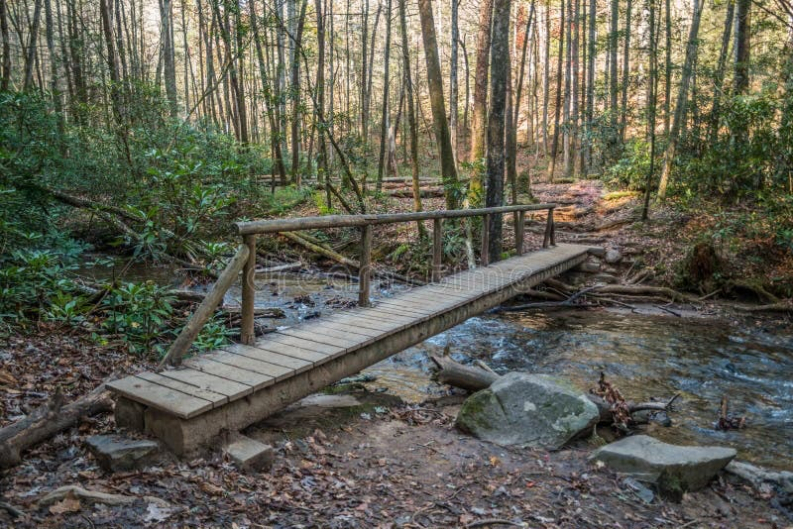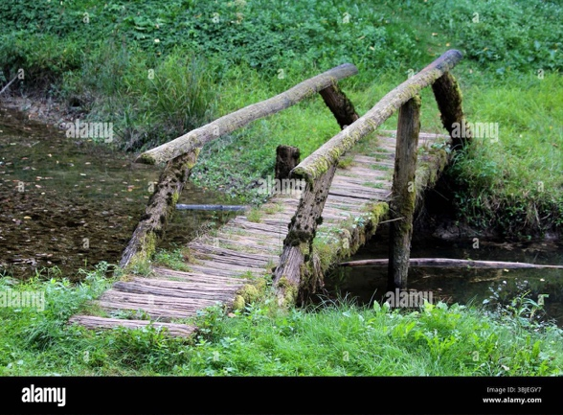

Option 3:
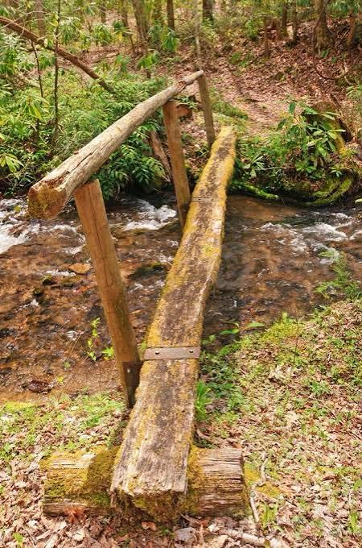
Our preferred option would be something more like option 2 as it has two side rails and is wide enough for walkers with pushchairs.

BENCHES
Option 1: Option 2:
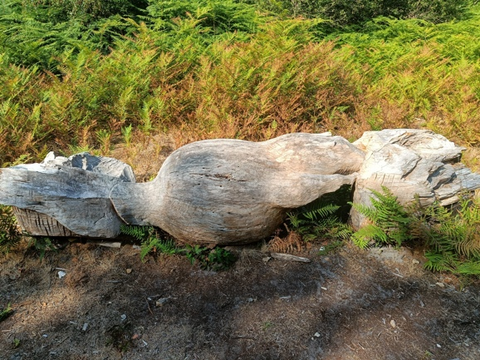
Option 3 - £475:
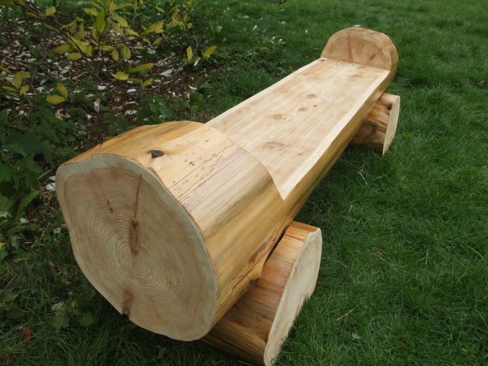
We propose to move forward with costing for both bridges and benches, to finalise the design proposal and seek funding from the solar farm fund.

Increasing biodiversity and natural habitats:
After the tree survey we would propose that any trees that need cutting down would instead be turned into veteran tree proxies – if they are suitable.
Other options still to be explored.

